Mustfa Ayyed Alhasanat

**Embedded systems’ project report**

Supervisor:

Dr. Aymen Mansor

**Contents**

* Main idea of the project
* Communication and control systems
* Electrical components
* Block diagram
* Flow chart
* Circuitry
* Blynk platform
* Pictures of the project
* Another example for the system
* Appendix

**Main idea of the project**

The procedure starts with the DHT11 reading the temperature around it. Then it sends it to Arduino which will do two things, the first is to control the fan through the relay by turn it on when the temperature in high, and turn it off after cooling the system. The second is to send that reading to the ESP via cables using the UART protocol. After that, the ESP connect to the Blynk server and send the reading so we can display it using the Blynk mobile app which is also connected to the server. The app also can send notifications when the temperature exceeds a particular value.

In this way, we can monitor the temperature around the house or an electrical system with ensuring that the fan will cool that system when it get heated.

**Communication and control systems**

The communication system used in this project is the UART (Universal Asynchronous Receiver Transmitter). Which needs two lines between the two devices (Arduino and ESP) on their receiver pins and transmitter pins to make a bidirectional communication, with a common ground between those two devices.

There is another communication happens in the project (the IOT system) between the ESP and the Blynk server, besides the smart phone and the server.

The control circuit driven by the Arduino (5V) used to control the relay’s input pin which will drive the power circuit (7.4V) that turn on/off the fan (DC motor).

**Electrical components**

* Arduino UNO
* ESP8266
* Breadboard
* Relay module
* DHT11 sensor
* MOSFET
* Potentiometer
* 1k Resistor
* Heat sink
* Jumper wires
* 7.4V battery
* DC motor
* USB cable
* Toy house (designed by a laser cutting machine CNC)
* Toy fan

**Block diagram**

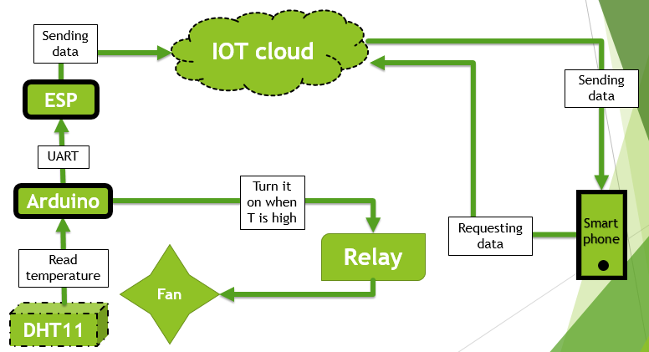

**Flow chart**

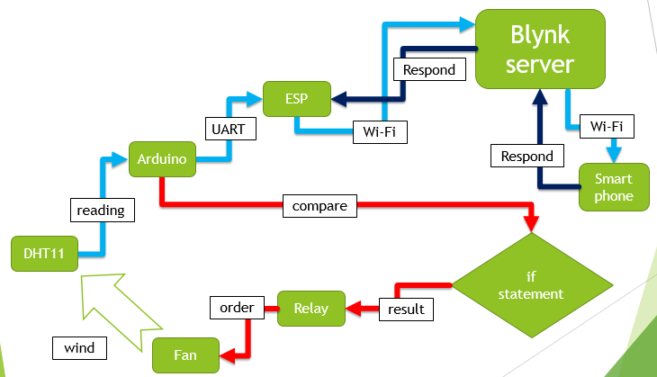

**Circuitry**

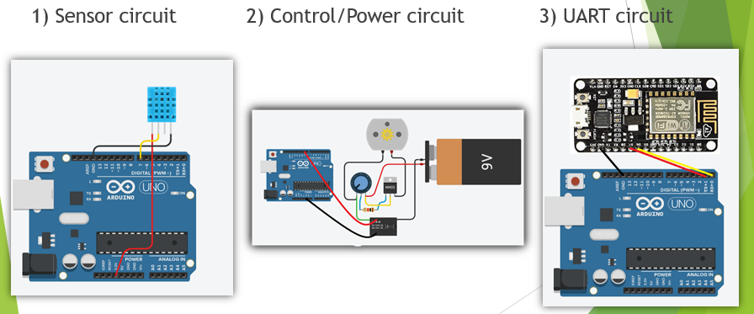

**Blynk platform**

Blynk is a wide platform contains a smart phone application and a library for Arduino with a web server that connect them all together.

The following picture shows the customized project I built using the Blynk app. It receives the temperature reading from the ESP and display it on the curve bar with its value. The other two small gadgets are for creating conditions and sending notifications to your smart phone.

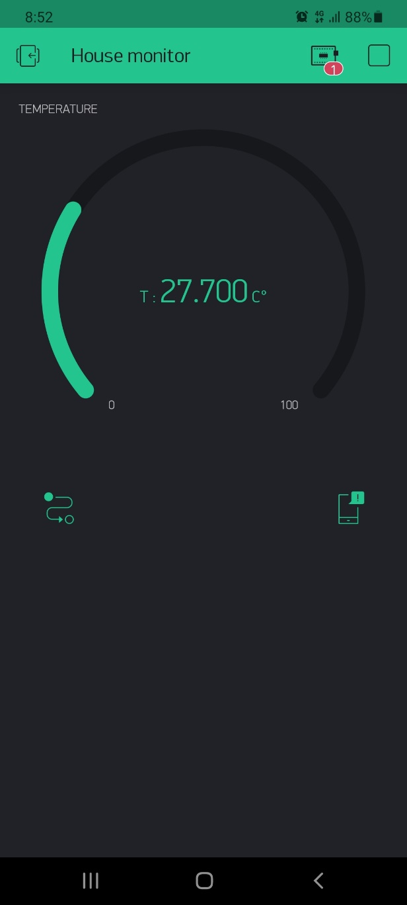

**Pictures of the project**

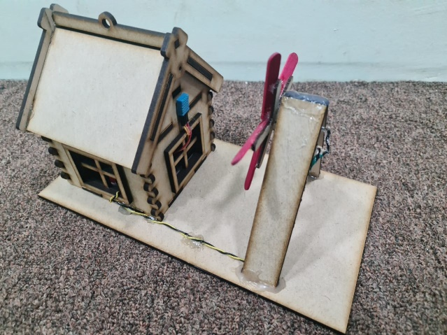 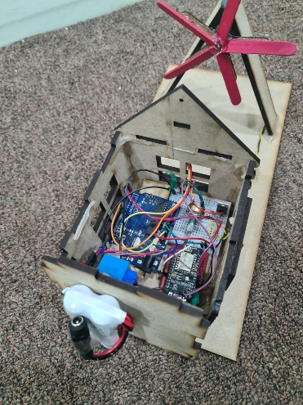

**Another example for the system**

We can use the IOT system for other applications. As example, we can connect a LED and a button to the ESP so we can light the LED remotely or constantly read the button state.

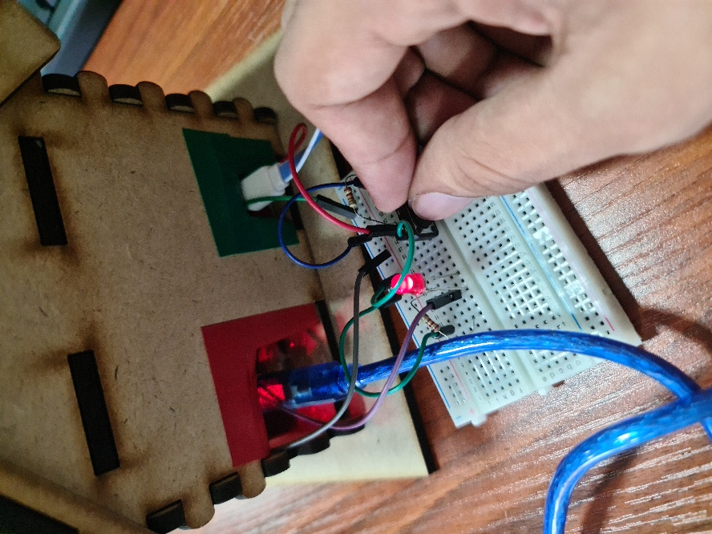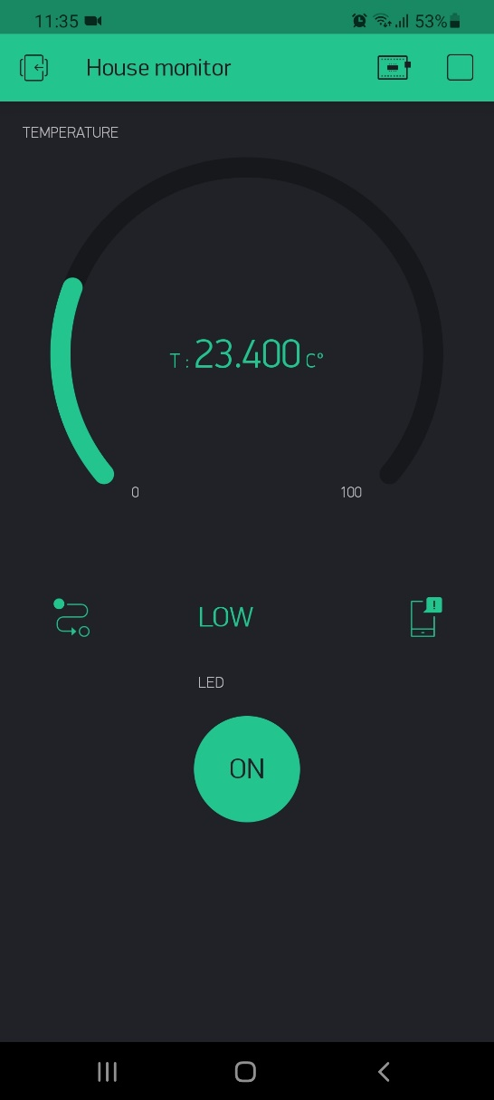

**Appendix**

Arduino code:

#include <DHT.h>

DHT dht(7, DHT11);

float temp;

void setup() {

Serial.begin(9600);

pinMode(9, OUTPUT);

digitalWrite(9, HIGH);

dht.begin();

}

void loop() {

temp = dht.readTemperature();

Serial.print(temp); Serial.print(" ");

if(temp > 30){

digitalWrite(9, LOW);

} else {

digitalWrite(9, HIGH);

}

delay(1500);

}

ESP code:

#define BLYNK_PRINT Serial

#include <ESP8266WiFi.h>

#include <BlynkSimpleEsp8266.h>

#include <SoftwareSerial.h>

SoftwareSerial mine(D7, D6);

float temp;

char auth[] = "xy6gBDXNPkGJk2VZFxjtmzfyf9QHT0mu";

char ssid[] = "Umniah-evo-Home-EE63";

char pass[] = "87654321";

BLYNK_READ(V5)

{

temp = mine.parseFloat();

if(temp != 0.0) {

Serial.println(temp);

Blynk.virtualWrite(V5, temp);

}}

void setup()

{

Serial.begin(115200);

mine.begin(9600);

Blynk.begin(auth, ssid, pass);

}

void loop()

{ Blynk.run(); }